**Virtual water supply chains’ diversity buffers cities of the Global South against climate change: a lesson from 181 cities**

**Abstract**

Water had a great influence on the rise and collapse of ancient civilizations. Nowadays, mankind faces water-related problems exacerbated by intensive farming, rapid urbanization, and climate change strikes. However, most of the water humanity is currently consuming is invisible. Although there is in-depth knowledge regarding the virtual water of cities of the Global North, virtual water flows in cities of the Global South are still fuzzy and lack generalizability. To bridge this gap, we compute and decompose Sothern’s cities’ virtual water (Blue and Grey) using Extended Environmental Input-Output Analysis (EE-IOA). While the scientific literature asserts that the North African region is triggered as a climate change hotspot that is exposed to strong temperature increases and high drought risk, results showed that North African cities are importing goods and services with larger quantities of embedded freshwater to bend local climate impacts and achieve regional water security. Results showed that the average blue virtual water is estimated to be 253 liters per capita/yr and 285 liters per capita/yr for virtual grey water. When decomposing the virtual water of the Global South we found that the major responsible sectors are “food” accounting for 37% of the total footprint, followed by “transport” with 24%, and “energy” with 22%. To place the climate-induced uncertainties in perspective, it is better to act in a pro-active approach to achieve regional water security by establishing local virtual water strategies.

**Keywords**

Virtual water; input-output analysis; cities; water security; urban sustainability; Global South

**Graphical abstract**



1. **Introduction**

Water plays a major role in urban development and ecosystems sustainability (Du et al., 2022). Thorough history, the first mankind’s revolutions testify on the relevance and the safety of water as a resource (e.g., ancient human civilizations: Mesopotamia, Egyptian, Greek and Roman) (Viollet, 2017). Currently, 97% of the water on Earth is saltwater, leaving only 2.5% as freshwater, only 1% of which is readily available for human consumption (Sun et al., 2021). Unfortunately, the world’s population is becoming increasingly dependent on this valuable resource, and major water-related crises are expected to merge (Graham et al., 2020). In our modern era, water has been widely acknowledged as a finite resource that should be addressed as an *“economic good”* to ensure regional and global water security (Hoekstra, 2003). From 2012 through 2020, the water issue has been in the top five global threats by impact for nine consecutive years (World Economic Forum, 2021). Moreover, the World Water Council’ Vision Report stated that there is a water management crisis which led both billions of people and the environment to suffer (Cosgrove and Rijsberman, 2014) because of the negative side effects (including land subsidence, and water quality degradation) of continued overexploitation of nonrenewable groundwater (Konikow and Kendy, 2005; Wada et al., 2010; Wada and Bierkens, 2014). If current consumption trends continue, two-thirds of the world's population will be living in water-stressed areas by 2025, with emerging countries facing the most severe predicament (UN-water, 2021).

At planetary scale, agricultural output accounts for over 90% of the overall Virtual Water (VW) consumption whereby 25% of this amount is reserved to food’s virtual water traded products (D’Odorico et al., 2019), this share has doubled between 1980s to 2007 (Dalin et al., 2012). Furthermore, between 1990s and 2015, the amount of food traded on foreign markets rose nearly three times faster than food production (Traverso and Schiavo, 2020). Thus, scholar have focused on analyzing the worldwide dynamics of virtual water to examine whether the VW trade, in a given region, compensates for lack of water for food production (such as these studies: (Dalin et al., 2014; Seekell et al., 2011; Wichelns, 2001)). Indeed, Scholars have discovered evidence that the VW trade relieves pressure on certain water-stressed places by allowing them to import and consume food produced in other parts of the world where water is abundant (Graham et al., 2020; Hoekstra and Mekonnen, 2016). The Middle East and North Africa (MENA) region serves as an example of how water trade can be used to conserve water. Even though the MENA region's food self-sufficiency is still at a low level, the region saved large quantities of national water and land based on the import of four primary crops, namely barley, maize, rice, and wheat, between 2000 and 2012 (Lee et al., 2019). Since it frequently requires 1000 kg of water to produce just 1 kg of food, importing food is more efficient than importing water directly (Mubako et al., 2013).

Unfortunately, we’re living in a changing climate system, climate fluctuations are putting an extra-burden on the water planning strategies including changes in precipitation events, runoff patterns, and droughts episodes (Maharaj et al., 2022). Many areas around the world are facing water-related issues such as Cape Twon in 2018 where the city experienced the *“Day-Zero”* (Burls et al., 2019; Maxmen, 2018). Climatologists have blown the whistle regarding the perturbation of rainfall amount from year-to-year and there will be heat waves accompanied with drought episodes (Cook et al., 2016; Lelieveld et al., 2016) such as those recently experienced in India from March to June (World Health Organisation, 2022). Climate change, is not only destabilizing water resource, but a larger system through the domino effect by impacting the food sector, for instance, we require one to two cubic meters of water, or 1,000 to 2,000 kilograms, to produce one kilogram of grain produced under rain-fed and favorable climatic circumstances (e.g., in Canada or Sweden); however, we require up to 3-fold of water to cultivate the same amount of gain in a dry country (e.g., in Israel or Algeria) where the metrological circumstances are less favorable (high temperature coupled with high evapotranspiration) (Chapagain and Hoekstra, 2003).

While the threat of disrupting human freshwater supplies has sparked great interest and debate in the policy, governance, academic, and corporate sectors as a way to generalize global sustainability efforts (Zhao et al., 2021). Yet, virtual water instruments and protocols are largely lacking, especially in the Global South. Only with few flagship examples such as the policy planning strategies initiated in Israel and Jordan to reduce the export of water-demanding products (virtual water strategy) (Shtull-Trauring and Bernstein, 2018), the physical and virtual water transfer schemes from south to north of China (Lu et al., 2022; Tian et al., 2022), and in Southern African region (Earle and Turton, 2003; Meissner, 2003). The existence of such hierarchical schemes or protocols can considerably influence the management practices to achieve regional; hence, global water security.

1. **Brief literature review on virtual water research: Definitions and accounting methods**

Water is required for all facets of the production process of goods and services, worldwide. However, water can be quantified via two distinct approaches (Hoekstra, 2003). The first is the ***production-based approach (physical water)***whereby the water is computed as being a *direct water* used in the production of a given commodity, the real water is *production* *site specifi*c since it is dependent on the conditions of production, such as the location and time of production, and the efficiency measures of local water use. The second is the ***consumption-based approach (virtual water)***whereby the water is compute as being *indirect water* used in the production of a given product but consumed or used in another geographic location, the virtual water is *consumption site specific* since it is dependent of the patterns of the final consumers behavior, local socioeconomic settings and geographical location (Novo et al., 2009). As such, there is minimal direct physical movement of water when items or services are moved from one location to another (apart from the water content of the product, which is quite insignificant in terms of volume). However, there is a large virtual water transfer. The virtual water, also known in the scientific literature as indirect, embedded, embodied, and exogenous water (Haddadin, 2003), is the quantity of water that has been consumed across the value chain of goods and services purchased from the global economic market (Hung, 2002), and it is often hidden from final consumers.

The virtual water concept was firstly proposed by the geographer Tony Allan in the early 1990s (Allan, 1993). After a decade, the notion was internationally accepted in December 2002 in Delft at the first international symposium on *virtual water* (the Netherlands). The virtual water is defined as *“the amount of water embodied in the international trade of products. Through the international trade in goods, water is virtually moved from the production country to the consumption country”* (Raimondi and Scoppola, 2022) aiming to measure *“measure of humans’ appropriation of freshwater resources”* (Hoekstra and Chapagain, 2011). Tony aimed to bringing attention to the fact that economic trade has reduced the shortage of water resources especially in the Middle East and North Africa (MENA). Since then, the chain of production for *"water"* has extensively used virtual water as a quantitative evaluation index. Nowadays, the technique that is most frequently employed to compute the virtual water accounting diverges into four main branches (Sun et al., 2021):

1. ***Virtual water accounting based on water footprint*** ***theory*** with a major focus on water trade in agricultural products and water footprint of crops. As the production of agricultural products depends mostly on rainfall, surface water, and groundwater, therefore the water footprint of agricultural products also includes the process water footprint of crop growth. In this case the water footprint is the sum of blue water and green water. Models frequently used to compute the water footprint of agricultural products includes the Crop Water Requirement Method (Allen, 1998), alongside to CROPWAT model, and H08 Global Hydrological Model (GHM) (Hanasaki et al., 2008; Sun et al., 2012) designed by FAO and based on Penman-Monteith model (Allen, 1998).
2. ***Virtual water accounting based in life cycle assessment (LCA)*** regulated by the International Organization for Standardization (ISO) 14046 (ISO 14046, 2014, p. 14). LCA is a process for evaluating how a product or service affects the environment at every stage of its life, from raw material extraction to manufacturing and usage to end-of-life disposal, recycling, or reuse (Boulay et al., 2013). LCA methodology includes several steps starting from setting goals, defining the scope, drawing the inventory accounting metric and units, evaluating the impact assessment, and interpretate results. In water, LCA includes the inputs and outputs of every unit process in the research system, in particular water consumption, water resource type, water quality parameters, water utilization mode, affected geographic location, time factor of water use, and compounds released into the air, water, and soil (Pfister et al., 2017).
3. ***Virtual water accounting based on input-output analysis (IOA)*** considered to be the most recent and used accounting method that aims to compute the water consumption per unit of a product or along a specific production chain of goods and services (Mubako et al., 2013). The input-output analysis model is a pure economic and mathematical model that uses national accounts theory, countries input-output tables, and linear algebra (Miller and Blair, 2009). Such model aims to display the water embedded during the exchanges among various sectors of the same country, or from goods and services purchased from the global economic market and consumed by local citizens. Virtual water accounting based on input-output models are preferred by scholars compared to virtual water theory because of their statistical significance and representativeness (Guan and Hubacek, 2007).

In these computation techniques, the virtual water can be computed for three main water types (i) ***Bleu water:*** the consumption of surface and groundwater during the production, ***(ii) Green water:*** refers to the quantity of water consumed by crops that comes from precipitation, and ***(iii) Gray water:*** representing the amount of fresh water necessary to dilute specific impurities (Water Footprint Network, 2022).

1. ***Additional evaluation metrics on the virtual water trade*** includes (i) *water security index (WSI)* and *water self-sufficiency index (WSSI)*  that are computed via the ratio of total water use to water availability (Smakhtin, 2004). (ii) *Theil Index (T)* that analyze the spatial differences that can be between and within regions (Shi et al., 2019). (iii) *Falkenmark Index (FI)* that aims to asses water scarcity in a given region (Falkenmark, 1989) it is computed by dividing the total renewable water of a given region by the average population of the same region in a given timeframe.(iv) *water quantity Scarcity Index (WQSI)* it can be displayed by the ratio of the blue water footprint to the available value water (Smakhtin et al., 2004). (v) *Water Quality Scarcity Index (WQASI)* is the ratio of the gray water footprint to the quantity of the local water resources available, and it alludes to the water scarcity caused by the discharge of pollutants (Zeng et al., 2013). (vi) *Virtual water dependency index (VRDI)* that measures the extent of regional water scarcity (Zhang et al., 2022).

While virtual water represent a key challenge for food and water security (FAO, 2012) especially to water-poor regions to overcome the scarcity of water and ensure food supply to local population (D’Odorico and Rulli, 2013), and conserving the world’s water supply (Chapagain et al., 2006; de Fraiture et al., 2004) one major drawback should be highlighted; when commercial benefits, rather than environmental ones, drive the flow of goods, virtual water trade results in a pronounced country interdependence and possibly harsh disparities (Seekell et al., 2011; Wichelns, 2010).

We chose the virtual water accounting based on the input-output as it focuses on a multifaceted analysis of the environmental sustainability, economic efficiency, and social equity of fresh water use and allocation. a technique that quantifies the connections between different parts of a complicated economic system using financial transactions

The market economy has been moving in the right direction since the 1970s, and economic growth has been accelerating quickly. The interchange of goods and services between regions has increased as there has been an increase in economic trade between various nations and regions. Because of the the nature of cities are being an open-economic systems, …… The virtual is trading is still ananolmous in the Global South.

To ensure both economic and environmental impacts are treated equally, the current study computes the two types of virtual water namely Blue (economic-driven) and Grey water (environmental-driven) for 181 cities belonging to the Global South (categorized into two classes Upper Middle-Income -UMICs- and Lower Middle-Income –LMICs-) and decomposes each water footprint by major final consumptions categories in order to allocate responsibilities to final demand sectors and trigger potential policy leverages. The final sample used for our analysis is based on 181 cities belonging to 23 countries of the Global South and hosting more than 30% of the world’s population. We believe that regional and global water security and efficient water use can be achieved through virtual water trade.

This paper aims at contributing to the literature by providing the first comprehensive and conclusive study on the virtual water for Global Southern cities based on 181 cities. Our study reduced the bias between the stat of the art of cities of the global North, with cities of the global South.

Decomposing VW footprints by sectors can evaluate sectoral water use efficiency and trigger to inform policy changes regarding water allocation under scarcity episodes.

* Provide first estimation of the virtual water of the Global South at city-scale 🡪 to extend the current literature review that focuses primarily only on cities of the Global North.
* Compare VW of cities of the global south regarding to income class (UMICs-LMICs) 🡪 to
* Decompose the VR by major final consumption categories 🡪 to stop water demanding sectors for each city.
* Inspect if cities of the Global South are importing goods and services from different water-abundant countries to achieve local water security and cushion climate change impacts.

1. **Methods and Materials**

**Data collection:** The concept of virtual water trading is fundamentally economic (Reimer, 2012) and closely related to the international trade theory which goes back to (Vanek, 1968) extension of the Huckster-Ohlin model but it is also geographical by nature (Carr et al., 2013); hence, two types of data were harvested. The first is urban expenditures surveys (UES) or consumers expenditures surveys (CES) (also denoted as city final demand vector - -) following COICOP-categorization of the 181 selected cities belonging to 23 countries of the Global South, see electronic supplementary information (ESI) file for further details. Data was retrieved from the office of statistics of each host-country. Notice that data collection methods and quality may vary from a country to country; hence, from a city to city (took as-is). Because of data scarcity in the Global South, cities final demand vectors - - were not taken at the same year because of the internal protocol of each host-country to establish and deploy the consumer expenditures surveys, some countries establish the surveys annually, while others quinquennial as such several limitations are to encounter while comparing results among selected cities (also highlighted in (Hachaichi and Baouni, 2021, 2020)). The second data constitutes of global Multi-Regional Input-Output (MRIO) tables retrieved from Eora’s global supply chain database (Lenzen et al., 2013, 2012). Eora provides multi-region input-output table (MRIO) model that provides a time series (from 1990 to 2021) of high-resolution Input-Output (IO) tables (capturing the inter-sectoral transfers amongst 15,909 sectors) with corresponding environmental and social satellite accounts () for 190 nations. We used Multi-Regional Input-Output tables (version 199.82) harmonized to 26 sectors to enable a transparent and an accurate comparison across selected cities. Notice that the current virtual water estimations of the Global South exclude footprints attributable to (i) government final consumption and (ii) gross fixed capital formation for which city-specific data was not available.

**Method:** To examine the distribution of the virtual water of the Global South we used an Environmental Extended Input-Output Analysis (EE-IOA) (Haberl et al., 2019; Kitzes, 2013; Miller and Blair, 2009; Raa, 2006, 2007) considered to be the most widely used technique to asses the virtual water (Sun et al., 2021) which enables the calculation of the virtual water flows among different industries and different regions, industries, and sectors (Chen et al., 2018, 2017) but also to compute the virtual water across the whole supply chain including physical and virtual water uses pertaining to imports for domestic consumption (Cai et al., 2017; Tian et al., 2018). Our analysis process is divided into two parallel pre-processing steps (Fig.1). The first in which we collected raw CES data in local currencies and transformed into cities’ final demand vectors () that matches to the respective sectors used by Eora (26 sectors), we aggregated the values (via a distributive process) to match Eora 26 sectors classification by constructing “correspondence table” that maps each value from the raw CES data to match Eora’s sectors. To use the virtual water coefficients provided by the Eora satellite accounts (), we converted cities’ final demand arrays () from local currencies into $US using the World Bank exchange rates (World Bank, 2021) and were mapped accordingly to the national import structure for each country to be used in the input-output calculations. In the second step, we computed the direct intensity vectors () as shown in Equation (2) (for each year corresponding the selected city’s final demand vector) for each virtual water category (Grey, and Blue water) using standard input-output techniques by dividing the corresponding values from the *Satellite account () matrix* (row number 2513 for the total blue water footprint, and 2514 for the total grey water footprint) by the total output vector compute via row-summation of the intermediate transaction matrix () and final demand matrix () for a given sector in a given year (Eq.1). The procedure result a vector of physical impacts (virtual water blue + gray) associated with one unit of output (1 US$ in basic prices), for each sector. After, we computed the final demand vector () by multiplying the direct intensity vector () in basic prices with the Leontief Inverse , as shown in Equation (3), giving a new matrix detailing all the upstream inputs in a unit of output (Leontief, 1986).

…(Eq.1)

…(Eq.2)

… (Eq.3)

Next, cities final demand vectors - - were converted from purchases price (PP) to base price (BP) on a sector by sector basis using national BP/PP ratios computed from Eora’s Multi-Regional Input-Output (MRIO) tables as preformed in (Pichler et al., 2017). To compute cities’ virtual water footprints (for each sector), we multiplied element wise the total demand vector () with the city final demand vector () as shown in Equation (4) giving the virtual water trade for each sector.

... (Eq.4)

Where is the virtual water per capita for a given city (m3/year), is the total intensity vector, and is the city final demand vector ($US/year).

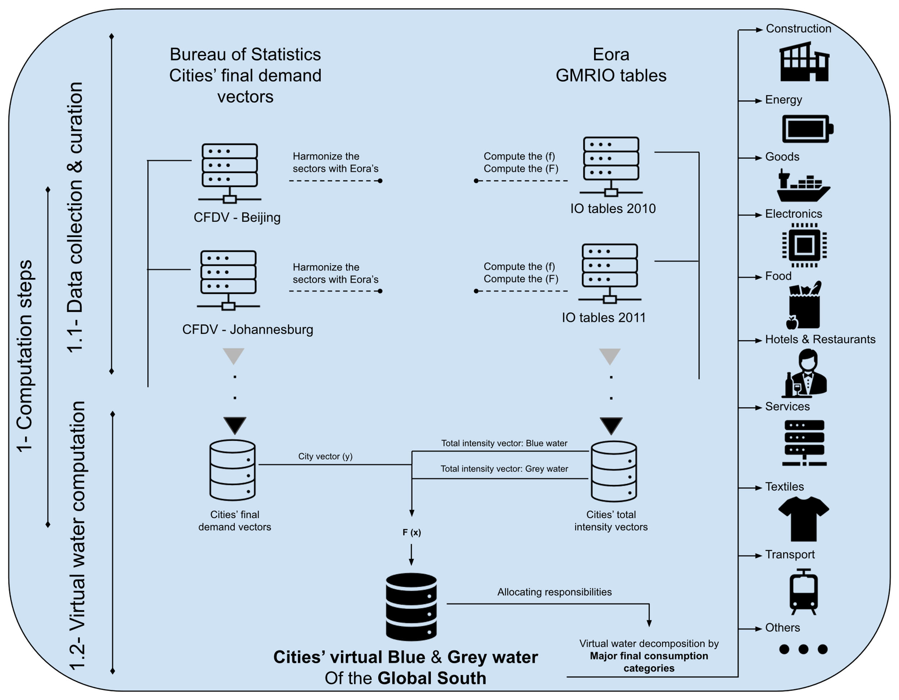

**Figure 1:** Method utilized to compute cities’ virtual water of the Global South and data dissemination by major final consumption categories.

1. **Results and discussions**

Results (Fig.2) shows that, on average, Global Southern cities’ virtual blue water footprint is estimated to 93 ± 78.5 liters per cap/year, and for the grey water footprint is estimated to 133 ± 144 liters per capita/year. This finding shows that, on average share across all cases, cities of the Global South are causing water pollution, elsewhere on the globe, more than importing fresh water embedded within goods and services. However, it is important to highlight that several Asian cities are associated with highest grey water footprints such as Atolls (Maldives) with 668 liters per capita/year, followed by Chinese cities Beijing, Guangdong, Tianjin, Jiangsu with 623, 517, 487 liters per capita/year, respectively.

**Figure 2:** Distribution of virtual water across selected cities of the Global South by type (Blue and Grey).

Decomposing the virtual water footprints by income classes by Lower Middle-Income -LMICs- and Upper Middle-Income -UMICs- (Fig.3) showed that for blue water footprint, Upper Middle-Income countries of the Global South, across all the selected cities, is estimated to 104 ± 72.2 liters per capita/year, and to 166 liters per capita/year. Whereas for Lower Middle-Income countries of the Global South we found that the blue water footprint is estimated to 72.4 ± 86.4 liters per capita/year. The Grey water footprints is estimated to 70.4 ± 45.9 liters per capita/year. Our results corroborate other research (Fu et al., 2022; Hachaichi and Baouni, 2020; Hoekstra and Mekonnen, 2012; Lenzen and Foran, 2001; Pichler et al., 2019; Souissi et al., 2022; Weinzettel et al., 2013) whereby affluence is a driving force for environmental footprints.

**Figure 3:** Distribution of virtual water across selected cities of the Global South by income class (Lower Middle-Income and Upper Middle-Income).

From a regional perspective (Fig.4), we discern that Asian cities accounts for both highest water footprints of grey and blue water with an average footprint across all Asian cities estimated to 139 ± 64.6 liter per capita/yr for blue water, and to 248.5 ± 166.8 liters per capita/yr for grey water. While Africa accounted for 72.78 ± 82.4 liters per capita/yr for blue water and to 60 ± 35 liters per capita/yr for grey water, and Latin America 23 ± 4.6 liters per capita for blue water and 26.7 ± 4.5 liters per capita/yr for grey water. Surprisingly, although that Latin America (8,520 US$) have the highest average income per capita then Asia (5,635 US$) and Africa (1,809 US$) (World Bank, 2022), their water footprints seems to be less flattened; nevertheless, water footprint is correlated to expenditures (Wiedmann et al., 2020), the more you spend you the higher your water footprint gets (Hachaichi and Baouni, 2020); hence, we highly believe that this issue is related the sample size took from Latin America (33 cities), compared to Asia and Africa which hare represented by 71 cities each (see electronic supplementary information file for further details).

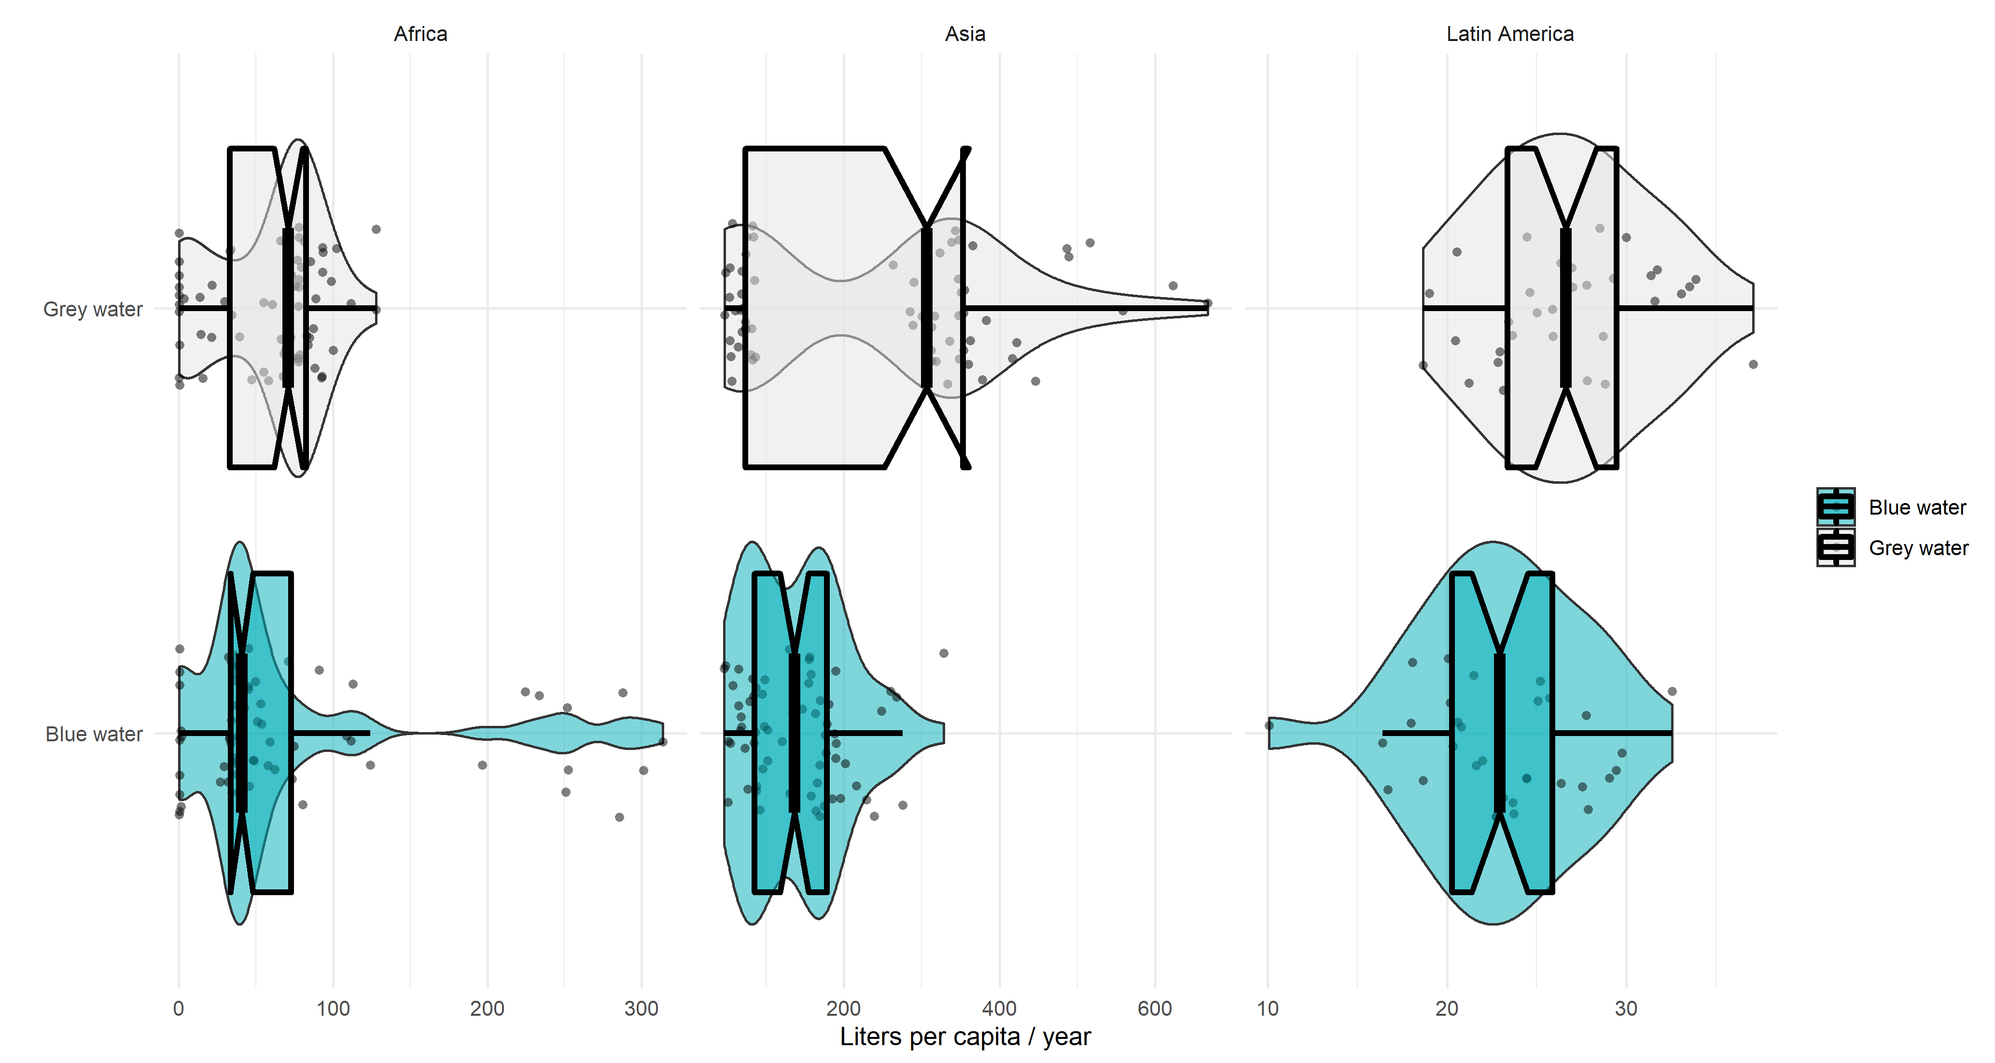

**Figure 4:** Distribution of virtual water across selected cities of the Global South by continent (Africa, Asia, and Latin America).

Results (Fig.3 and 4) for the blue water category shows that Asian and North African cities are the among the highest Global Southern cities that import fresh water from the global economic market. For Asia, three Chinese cities have the highest quantities of imported water embedded within goods and services namely Beijing with 328.45 liters per capita/yr, followed by Guangdong with 267.42 liters per capita/yr, and Jiangsu with 248 liters per capita/yr. From North African region, we found Tunis (Tunisia) is associated with a water footprint estimated to 314.65 liters per capita/yr, while Casablanca, Tangier and Laayoun (Morocco) are associated with the respected total embedded fresh water of 301.1, 285.6, and 251.65 liters per capita/yr. North Africa is considered a climate change hot spots (Diffenbaugh and Giorgi, 2012; Schmitz et al., 2013) with a strong temperature increase (Nashwan et al., 2019; Zeroual et al., 2019) and high drought risks (Hertig and Jacobeit, 2008), particularly there are greater climate vulnerabilities in term of water resources (Lionello and Scarascia, 2018; Tramblay et al., 2018) in Algeria, Egypt, Libya, Morocco, and Tunisia as highlighted by (Schilling et al., 2020) and expanding to Middle-East and North Africa (MENA) region (Tamea et al., 2016) with major socioeconomic implications (Tamea et al., 2016) (given the fact that all North African countries -except Algeria- are dependent on agriculture as the primary input for GDP and particularly employment, and any fluctuations may lead to social instability and most likely encourage climate immigration towards Europe both legal and illegal). The combination of climate change and rapid population expansion in North Africa is more likely to exacerbate the already precarious water situation (Haddadin, 2001; KC and Lutz, 2014). Countries belonging to this region are among the highest countries with the highest Hydrological Water Stress Index (HWSI) and Social Water Scarcity Index (SWSI); therefore, this may explain why Norther African cities are purchasing goods and services from the global economic market with high quantities of embedded freshwater.

Rainfall is projected to decrease (according to CMIP5 from the GCM) by -10% to -20% for large parts in North Africa (IPCC, 2013) while (Droogers et al., 2012) by simulating future water resources (until 2050) found that the region will decrease in water supply by -12% and an increase in water demand by +50%. This projections are confirmed via different approached namely by Global Climate Models (GCMs) as in (Collins et al., 2013), Regional Climate Models (RCMs) as in (Bucchignani et al., 2018) and statistical projections as in (Hertig and Jacobeit, 2008). However, it is important to highlight that anthropogenic-induced activities having a far greater impact on North African aquifers than climate variability (Leduc et al., 2017; Lezzaik and Milewski, 2018), overexploitation has resulted in a reduction in groundwater levels in various Maghreb subregions during the last 50 years (Treidel et al., 2011; Zkhiri et al., 2019) this has also resulted in a decrease in the quality of water in certain aquifers of the region and put a heavy burden on water availability.

On the other hand, results for the Grey water category showed that Atolls (Maldives) have the highest virtual water consumption across all the selected cities with value estimated to 667.99 liters per capita/yr, the Maldives considering its geographical attributes it’s facing several environmental risks among them all water scarcity and food insecurity (Zubair and Nijamdeen, 2022) alongside to being the 1st South Asian touristic destination. The city heavily relays on the global economic market to satisfy local development, local citizens and tourists’ requirements. Atolls is followed by the three Chinese’ major cities such as Beijing with 622.8 liters per capita/yr. Chinese cities represent a share of the top Global Southern cities’ freshwater footprint Guangdong with 516.64 liters per capita/yr, and Tianjin with 486.80 liters per capita/yr.



**Figure 5:** Top 20 Global Southern cities with highest values of virtual water.

Cities are economically open systems that rely on imported commodities and services from national and international markets to satisfy their local development needs (Hachaichi and Baouni, 2020; Pichler et al., 2017). Commodity trade globalization helps to increase food supply and population sustainability by lowering reliance on local resources (Falkenmark et al., 2004; Porkka et al., 2013). Globalization, on the other hand, fosters the spread of crises by resulting in complex, interrelated production-consumption systems that are prone to collapse (Helbing, 2013). Despite the existence of several initiatives recognizing cities' inherent socio-metabolic openness (for instance the virtual water trade initiative –VWT-), which invariably leads to resource use and associated out-boundaries pollution occurring outside of city boundaries, most scholars and policymakers still concentrate their assessment efforts solely on physical water flows within regions’ administrative boundaries (Vallino et al., 2021) and ignoring the virtual water. Most of the countries with developing economies are trying to grow so fast, without paying attention to the environmental degradation generated during this process (Hachaichi and Baouni, 2019). One approach to achieve regional sustainability is by decomposing virtual impacts by major consumption categories to ensure the right allocation of responsibilities and trigger effective policy leverages.

Decomposing the virtual water footprint of top 20 cities of the Global South with highest virtual water footprints (Fig.5) shows uneven sectoral distribution of the footprints. For instance, Tunis (Tunisia) the “Food” sector account for 93% of the total freshwater footprint, followed by “Transport” with 3%, as stated earlier North African countries are extremely vulnerable to climate variabilities and fluctuated precipitation regimes (Prudhomme et al., 2014), and mostly their agriculture is qualified as “rain-fed” agriculture (Schilling et al., 2020); hence, North African cities tends to rely heavily on the global economic market for agriculture-related products to mitigate the impact of climate change and the local mismanagement of water resources. On the other hand, the sector of “Services” represents the bulk of the virtual water footprint for the city of Atolls (Maldives) by a share estimated to 70%, followed by “Food” sector with a footprint estimated to 10%. Not surprisingly, Maldives is a pure touristic country, and therefore it imports most of its touristic services, worldwide.

Considering the Grey water footprint, results showed that, unlike other cities virtual water distribution, Chinese cities are causing water pollution elsewhere, and the vast majority of this pollution is allocated to the “Transport” sector where, for instance, in Beijing represents 41.7% of the total Grey water footprint -of the city knowing that China detains the highest share (33.5%) of owning the German car brands (such as BMW) worldwide, followed by the USA with 13.2% (Statista, 2022)-. In China, “Food” sector ranked the second representing 28% to the total footprint knowing that China has experienced a crop failure which led to a significant rise in wheat imports, contributing to a doubling of global wheat prices (Sternberg, 2012), followed by the “Energy” sector with 22%. China is currently under a major economic development and requires energy to support its growth (Lin and Wang, 2012; Yin and Lam, 2021).

The scientific literature asserts that agricultural commodities are by far the most water-intensive traded products (Hoekstra and Chapagain, 2007), and they are destined for human consumption in major part. However, notice that this is not always the case as our results show that while in the Blue virtual water category is dominated indeed by the “Food” sector, the Grey virtual water is dominated by the “Transport” sector.

**Figure 6:** Top 20 Global Southern cities with highest values of virtual water decomposition by major final consumption categories.

Decomposing the water footprint by major final consumption categories and by income category show that almost the same sectoral decomposition by income class but not by type of virtual water. For instance, Lower Middle-Income Countries Grey virtual water is dominated by “Transport” sector with a share estimated to 48% of the total Grey virtual water, followed closely by the “Food” sector with 23%. A switch in the flip is triggered, while LMICs cities Grey virtual water is dominated by “Transport” sector, LMICs Blue virtual water is dominated by the “Food” sector accounting for 43% followed by the “Transport” sector with 27%. Following the same structural decomposition of LMICs’ virtual water, Upper Middle-Income Countries (MICs) Blue virtual water is monopolized by the “Food” sector (32%), followed by “Energy” (26%), and “Transport” (23%). On the other hand, UMICs Grey virtual water is dominated by “Transport” sector (with 34%), followed by “Energy” sector (with 23%), and “Food” sector with 22%. However, it is noteworthy that UMICs virtual water decomposition accounts higher values in the “Services” sector (estimated to 4%) compared to LMICs (estimated to 1%). This finding suggest that LMICs and UMICs are in different stages of economic development; hence, they requires different inputs from different sectors to satisfy their local growth requirements.



**Figure 7:** Global South’s virtual water decomposition by major consumption categories.

From a regional perspective (Fig.8), results showed almost the same sectoral composition across continent whereby for the Grey virtual water is mostly dominated by the “Transport” sector, followed by the “Food” sector. However, results also display that Asian cities are somehow having higher water footprints issued attributed to the services sector compared to African and Latin American cities. On the other hand, the blue water footprint across continent showed a major dominance of the “Food” sector, followed by “Transport” and “Energy”. Notice that fundamental and systemic shifts are reshaping value chains, commerce, and financial flows as a result if the global energy revolution, and each country and thus each city will face unique energy-related challenges; hence, water and food issues. With the value of fossil fuels is expected to decline in the near future, resource-rich countries of the Global South (such as Algeria, Libya, Nigeria, Venezuela, etc.) should anticipate the problem of “standard assets”. For instance, Algeria fossil fuels export constitutes 96% of the total exports contributing up to 60% to the country’s GDP.

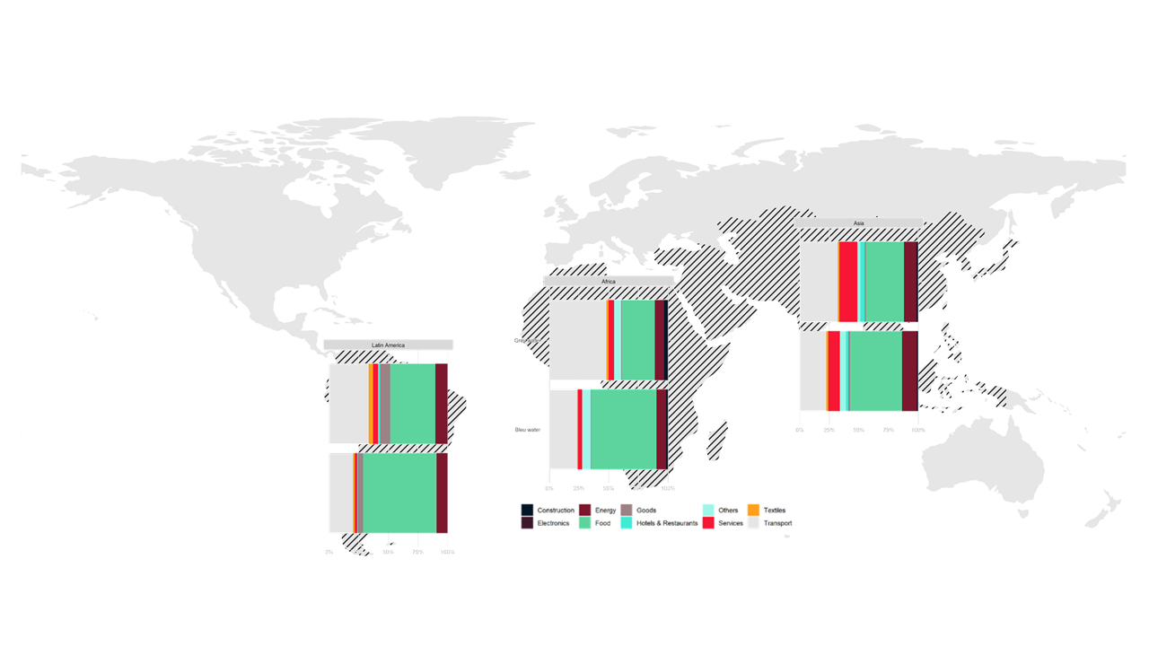

**Figure 8:** Global South’s virtual water decomposition by major consumption categories and by continent.

Decomposing the water footprint by major final consumption categories, major industrial sectors and income class. Results showed that almost the same distribution across sectors except for the “Services” sectors which counts highest shares both for blue and grey water footprints in cities belonging to Upper Middle-Income Countries (UMICs). Overall, the sectoral decomposition of both water footprints are following the same pattern by major industrial categories except for “Hotels & Restaurants” sector with accounts higher shares in UMICs compared to those of LMICs for the tertiary category, same applied for the “Services” sector in the light manufacturing category. According to Fig.9 we notice that the heavy industry category is dominated by the “Transport” sector with a share of 98%, followed by “Construction” sector with almost 2%. The light manufacturing sector is dominated by the “Food” sector which accounts for an average share of 78% of the total water footprint. On the other hand, primary industry category is dominated by the “Energy” sector representing a total share of 93% followed by “Goods” and “Commodities” with 7%. While the tertiary category is dominated by the “Services” sector with a share of 96% for cities belonging to Lower Middle-Income Countries (LMICs), and around 75% for cities belonging to Upper Middle-Income Countries (UMICs).



**Figure 9:** Global South’s virtual water decomposition by industrial sectors and income classes.

Virtual water is predicted to transfer from water-rich regions to those with limited water supplies, resulting in a more equitable distribution of water resources (Allan, 1993, Allan, 1997). VWT has the potential to become an optimal approach for reducing local water stress and resolving the conflicts produced by global water supply and demand imbalances (Steffen et al., 2015; Wang et al., 2020; Zhao et al., 2015). Moreover, because of the huge distances and accompanying expenses, real water trade between water-rich regions and water-poor regions is impracticable; Nevertheless, trading water embedded in goods and services in feasible (Carr et al., 2012; Hoekstra, 2003). Virtual water trade is expected to triple by 2100 whereas physical water trade is expected to double. From a regional perspective, virtual water exports are to be abundant in North America basins, as well as the La Plata and Nile Rivers, whereas much of Africa, India, and the Middle East rely significantly on virtual water imports by the end of the century (Graham et al., 2020). Our results corroborates these findings, we found that cities belonging to the North African region (Tunis, Algiers, Marrakesh, and Tangiers) are importing freshwater-intensive commodities (goods and services) from geographically diverse water-abundant countries which can provide water security and buffering these cities against climate change impacts at the local scale and adapt to drought episodes though the purchase of products and services with water-demanding commodities instead of producing them locally (Graham et al., 2020). The use of this extra source could be a tool for achieving regional water security in the North African region (D’Odorico et al., 2014; Tamea et al., 2016, 2014) and an effective instrument for achieving multiscalar water security. Similarly, (Allan, 1998, 1997) results showed that Middle Eastern countries were importing commodities with higher embedded water which helped in flattening water shortages in the region, and reduce the likelihood of a long-predicted major conflicts over water.

Overall, our results support proactive policy decisions aiming at attributing environmental responsibility for water scarcity and advocate for action to avoid water ecological consequences of international trade. Cities of the Global South should diversify their imports of goods and services with higher embedded virtual water from different locations in order to acquire a resilient virtual water posture and help them to achieve regional water security.

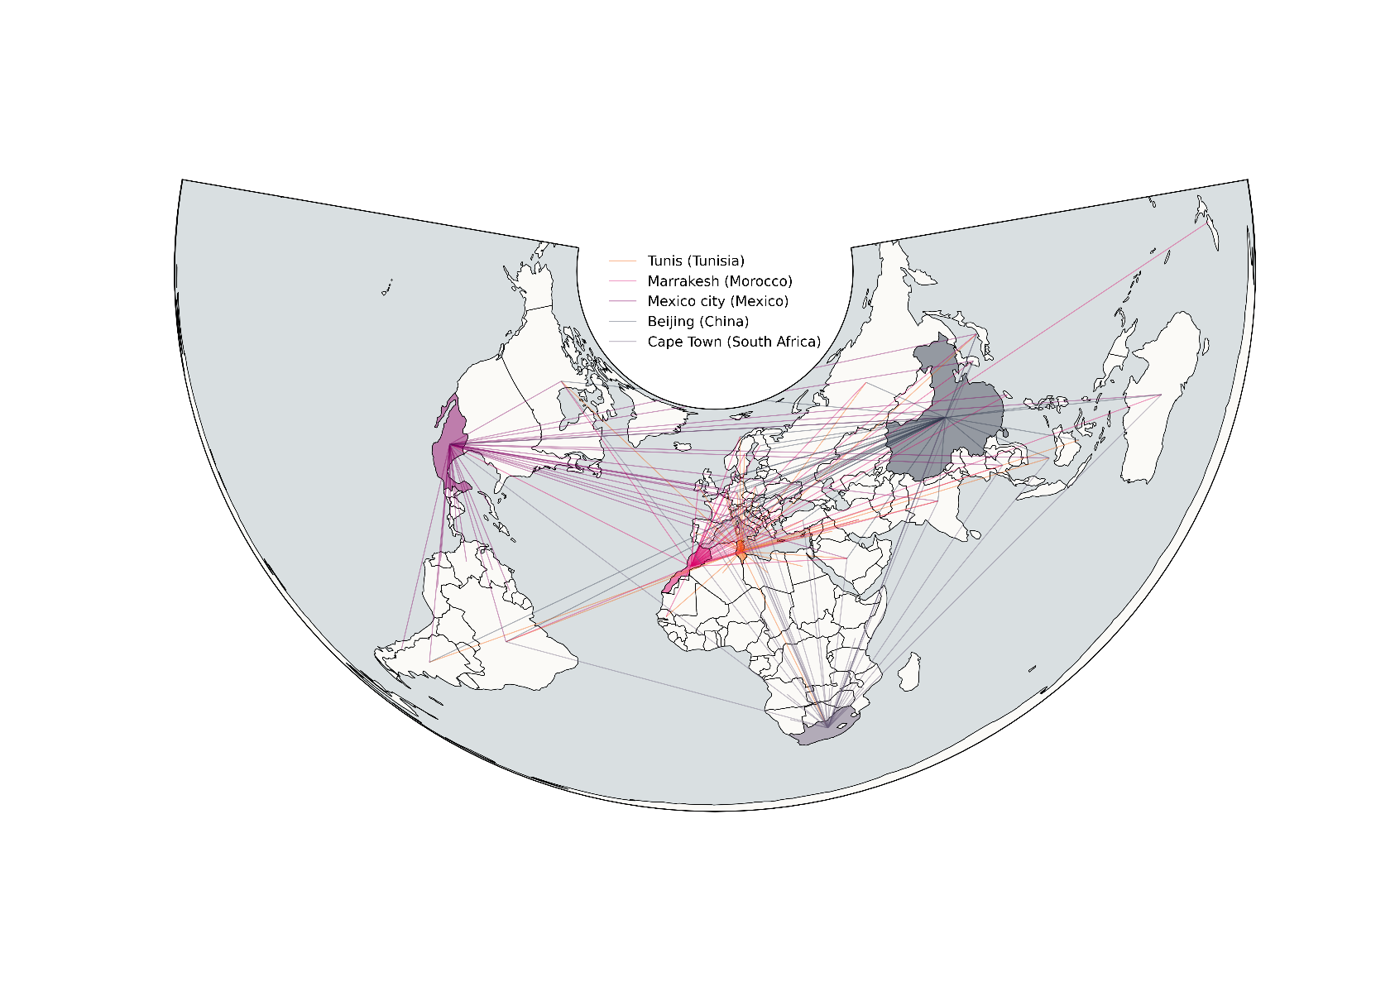

**Figure 10:** Top 40 locations of Global South’s virtual water imports from the global economic market.

1. **Conclusion**

Water is not unequally distributed across countries and regions, and its availability is highly dependent on the future pathways of Earth’s climate system. Moreover, most of the water humanity is currently consuming is invisible by nature. It is embedded within goods and services purchased from the global economic market and consumed by final consumers broken down into three main categories: household final consumption, government consumption and fixed capital formation. Supply and demand for water encompasses other non-climatic factors that might have a considerable effect on water including population dynamics, economic growth, affluence, and geopolitics. Hence, water supply is bounded with time, geography and climate regime.

To our knowledge, this study provides the first estimations of the virtual water of cities of the Global South in a cross city-comparison fashion. We computed the virtual water (both grey and blue) derived from the global trade of 181 cities belonging to 23 countries of the Global South and examined their regional distribution. In the analysis process we distinguish between income classes (LMICs and UMICs), and major consumption sectors, as well as major industrial categories (primary industries, secondary industries, and tertiary industries).

Results showed that the average blue virtual water is estimated to 253 liters per capita/yr and for grey water is estimated to 285 liters per capita/yr. When decomposing the virtual water of the Global South we found that the major responsible sectors is “Food” sector accounting for 37% of the total footprint, followed by “Transport” with 24% and “Energy” with 22%. A switch in the flip is triggered while decomposing the grey water footprint, where the “Transport” sector accounted for the bulk of overall Grey water footprint with a share estimated to 36%, followed by the “Food” sector with a share estimated to 22%. Further analysis showed that water-scarce regions (especially North African region as being on the frontlines of climate change impacts: frequents droughts episodes, high temperatures) tend to import virtual water embedded within goods and services mostly in form of “Food” products representing 37% of the total blue water footprint, thereby reducing pressure on local water supplies. It is also vital to be prepared to manage the virtual part of water while making fundamental decisions or evaluating future choices and strategies aiming regional water security.

We know that water is not a standalone problem, but rather it manifests through a highly complex system merging food security, energy accessibility and social stability. For future research, we will couple the future climate scenarios driven from the Global Climate Models (GCMs) established by Coupling Models Inter-Comparison Project (CMIP) and future imports of the cities of the Global South using Partial Convolutional Neural Networks (PCCN) to examine the possibilities and probabilities if Global Southern’ cities will adjust their imports patterns when climate impacts start being felt. In addition, one important research question would be also to study the implications of such resource’s uncertainties with the regional migration of people from the South towards the North.

1. **References**

Allan, J.A., 1993. Fortunately there are substitutes for water otherwise our hydro-political futures would be impossible. Priorities for water resources allocation and management 13, 26.

Allan, T., 1998. Watersheds And Problemsheds [WWW Document]. URL https://ciaotest.cc.columbia.edu/olj/meria/meria398_allan.html (accessed 4.21.22).

Allan, T., 1997. ‘Virtual water’: a long term solution for water short Middle Eastern economies? 21.

Allen, R.G., 1998. Crop Evapotranspiration-Guideline for computing crop water requirements. Irrigation and drain 56, 300.

Boulay, A.-M., Hoekstra, A.Y., Vionnet, S., 2013. Complementarities of Water-Focused Life Cycle Assessment and Water Footprint Assessment. Environ. Sci. Technol. 47, 11926–11927. https://doi.org/10.1021/es403928f

Bucchignani, E., Mercogliano, P., Panitz, H.-J., Montesarchio, M., 2018. Climate change projections for the Middle East–North Africa domain with COSMO-CLM at different spatial resolutions. Advances in Climate Change Research, Including special topic on China Energy Modeling Forum 9, 66–80. https://doi.org/10.1016/j.accre.2018.01.004

Burls, N.J., Blamey, R.C., Cash, B.A., Swenson, E.T., Fahad, A. al, Bopape, M.-J.M., Straus, D.M., Reason, C.J.C., 2019. The Cape Town “Day Zero” drought and Hadley cell expansion. npj Clim Atmos Sci 2, 1–8. https://doi.org/10.1038/s41612-019-0084-6

Cai, B., Wang, C., Zhang, B., 2017. Worse than imagined: Unidentified virtual water flows in China. Journal of Environmental Management 196, 681–691. https://doi.org/10.1016/j.jenvman.2017.03.062

Carr, J.A., D’Odorico, P., Laio, F., Ridolfi, L., 2013. Recent History and Geography of Virtual Water Trade. PLOS ONE 8, e55825. https://doi.org/10.1371/journal.pone.0055825

Carr, J.A., D’Odorico, P., Laio, F., Ridolfi, L., 2012. On the temporal variability of the virtual water network. Geophysical Research Letters 39. https://doi.org/10.1029/2012GL051247

Chapagain, A.K., Hoekstra, A.Y., 2003. Virtual water flows between nations in relation to trade in livestock and livestock products. UNESCO-IHE Delft, The Netherlands.

Chapagain, A.K., Hoekstra, A.Y., Savenije, H.H.G., 2006. Water saving through international trade of agricultural products. Hydrology and Earth System Sciences 10, 455–468. https://doi.org/10.5194/hess-10-455-2006

Chen, W., Wu, S., Lei, Y., Li, S., 2018. Virtual water export and import in china’s foreign trade: A quantification using input-output tables of China from 2000 to 2012. Resources, Conservation and Recycling 132, 278–290. https://doi.org/10.1016/j.resconrec.2017.02.017

Chen, W., Wu, S., Lei, Y., Li, S., 2017. China’s water footprint by province, and inter-provincial transfer of virtual water. Ecological Indicators 74, 321–333. https://doi.org/10.1016/j.ecolind.2016.11.037

Collins, M., Knutti, R., Arblaster, J., Dufresne, J.-L., Fichefet, T., Friedlingstein, P., Gao, X., Gutowski, W.J., Johns, T., Krinner, G., Shongwe, M., Tebaldi, C., Weaver, A.J., Wehner, M.F., Allen, M.R., Andrews, T., Beyerle, U., Bitz, C.M., Bony, S., Booth, B.B.B., 2013. Long-term Climate Change: Projections, Commitments and Irreversibility. Climate Change 2013 - The Physical Science Basis: Contribution of Working Group I to the Fifth Assessment Report of the Intergovernmental Panel on Climate Change 1029–1136.

Cook, B.I., Anchukaitis, K.J., Touchan, R., Meko, D.M., Cook, E.R., 2016. Spatiotemporal drought variability in the Mediterranean over the last 900 years. Journal of Geophysical Research: Atmospheres 121, 2060–2074. https://doi.org/10.1002/2015JD023929

Cosgrove, W.J., Rijsberman, F.R., 2014. World water vision: making water everybody’s business. Routledge.

Dalin, C., Hanasaki, N., Qiu, H., Mauzerall, D.L., Rodriguez-Iturbe, I., 2014. Water resources transfers through Chinese interprovincial and foreign food trade. Proceedings of the National Academy of Sciences 111, 9774–9779. https://doi.org/10.1073/pnas.1404749111

Dalin, C., Konar, M., Hanasaki, N., Rinaldo, A., Rodriguez-Iturbe, I., 2012. Evolution of the global virtual water trade network. Proceedings of the National Academy of Sciences 109, 5989–5994. https://doi.org/10.1073/pnas.1203176109

de Fraiture, C., Cai, X., Amarasinghe, U., Rosegrant, M., Molden, D., 2004. Does international cereal trade save water?: the impact of virtual water trade on global water use. Iwmi.

Diffenbaugh, N.S., Giorgi, F., 2012. Climate change hotspots in the CMIP5 global climate model ensemble. Climatic Change 114, 813–822. https://doi.org/10.1007/s10584-012-0570-x

D’Odorico, P., Carr, J., Dalin, C., Dell’Angelo, J., Konar, M., Laio, F., Ridolfi, L., Rosa, L., Suweis, S., Tamea, S., Tuninetti, M., 2019. Global virtual water trade and the hydrological cycle: patterns, drivers, and socio-environmental impacts. Environ. Res. Lett. 14, 053001. https://doi.org/10.1088/1748-9326/ab05f4

D’Odorico, P., Carr, J.A., Laio, F., Ridolfi, L., Vandoni, S., 2014. Feeding humanity through global food trade. Earth’s Future 2, 458–469. https://doi.org/10.1002/2014EF000250

D’Odorico, P., Rulli, M.C., 2013. The fourth food revolution. Nature Geosci 6, 417–418. https://doi.org/10.1038/ngeo1842

Droogers, P., Immerzeel, W.W., Terink, W., Hoogeveen, J., Bierkens, M.F.P., van Beek, L.P.H., Debele, B., 2012. Water resources trends in Middle East and North Africa towards 2050. Hydrology and Earth System Sciences 16, 3101–3114. https://doi.org/10.5194/hess-16-3101-2012

Du, Y., Fang, K., Zhao, D., Liu, Q., Xu, Z., Peng, J., 2022. How far are we from possible ideal virtual water transfer? Evidence from assessing vulnerability of global virtual water trade. Science of The Total Environment 828, 154493. https://doi.org/10.1016/j.scitotenv.2022.154493

Earle, A., Turton, A., 2003. The virtual water trade amongst countries of the SADC. Hoekstra, AY (Ed.).

Falkenmark, M., 1989. The Massive Water Scarcity Now Threatening Africa: Why Isn’t It Being Addressed? Ambio 18, 112–118.

Falkenmark, M., Rockstrom, J., Rockström, J., 2004. Balancing Water for Humans and Nature: The New Approach in Ecohydrology. Earthscan.

FAO, E., 2012. Coping with water scarcity: an action framework for agriculture and food security. Food and Agriculture Organization of the United Nations, Rome.

Fu, T., Xu, C., Yang, L., Hou, S., Xia, Q., 2022. Measurement and driving factors of grey water footprint efficiency in Yangtze River Basin. Science of The Total Environment 802, 149587. https://doi.org/10.1016/j.scitotenv.2021.149587

Graham, N.T., Hejazi, M.I., Kim, S.H., Davies, E.G.R., Edmonds, J.A., Miralles-Wilhelm, F., 2020. Future changes in the trading of virtual water. Nat Commun 11, 3632. https://doi.org/10.1038/s41467-020-17400-4

Guan, D., Hubacek, K., 2007. Assessment of regional trade and virtual water flows in China. Ecological Economics 61, 159–170. https://doi.org/10.1016/j.ecolecon.2006.02.022

Haberl, H., Wiedenhofer, D., Pauliuk, S., Krausmann, F., Müller, D.B., Fischer-Kowalski, M., 2019. Contributions of sociometabolic research to sustainability science. Nat Sustain 2, 173–184. https://doi.org/10.1038/s41893-019-0225-2

Hachaichi, M., Baouni, T., 2021. Virtual carbon emissions in the big cities of middle-income countries. Urban Climate 40, 100986. https://doi.org/10.1016/j.uclim.2021.100986

Hachaichi, M., Baouni, T., 2020. Downscaling the planetary boundaries (Pbs) framework to city scale-level: De-risking MENA region’s environment future. Environmental and Sustainability Indicators 5, 100023. https://doi.org/10.1016/j.indic.2020.100023

Hachaichi, M., Baouni, T., 2019. The Carbon Footprint Model as a Plea for Cities towards Energy Transition: The Case of Algiers Algeria. International Journal of Energy and Environmental Engineering 13, 255–262.

Haddadin, M.J., 2003. Exogenous water: A conduit to globalization of water resources, in: Virtual Water Trade: Proceedings of the International Expert Meeting on Virtual Water Trade. Value of Water Research Report Series. pp. 159–169.

Haddadin, M.J., 2001. Water Scarcity Impacts and Potential Conflicts in the MENA Region. Water International 26, 460–470. https://doi.org/10.1080/02508060108686947

Hanasaki, N., Kanae, S., Oki, T., Masuda, K., Motoya, K., Shirakawa, N., Shen, Y., Tanaka, K., 2008. An integrated model for the assessment of global water resources – Part 1: Model description and input meteorological forcing. Hydrology and Earth System Sciences 12, 1007–1025. https://doi.org/10.5194/hess-12-1007-2008

Helbing, D., 2013. Globally networked risks and how to respond. Nature 497, 51–59. https://doi.org/10.1038/nature12047

Hertig, E., Jacobeit, J., 2008. Downscaling future climate change: Temperature scenarios for the Mediterranean area. Global and Planetary Change, Mediterranean climate: trends, variability and change 63, 127–131. https://doi.org/10.1016/j.gloplacha.2007.09.003

Hoekstra, A., 2003. Virtual Water Trade: Proceedings of the International Expert Meeting on Virtual Water Trade 1–244.

Hoekstra, A.Y., Chapagain, A.K., 2011. Globalization of Water: Sharing the Planet’s Freshwater Resources. John Wiley & Sons.

Hoekstra, A.Y., Chapagain, A.K., 2007. Water footprints of nations: Water use by people as a function of their consumption pattern, in: Craswell, E., Bonnell, M., Bossio, D., Demuth, S., Van De Giesen, N. (Eds.), Integrated Assessment of Water Resources and Global Change: A North-South Analysis. Springer Netherlands, Dordrecht, pp. 35–48. https://doi.org/10.1007/978-1-4020-5591-1_3

Hoekstra, A.Y., Mekonnen, M.M., 2016. Imported water risk: the case of the UK. Environ. Res. Lett. 11, 055002. https://doi.org/10.1088/1748-9326/11/5/055002

Hoekstra, A.Y., Mekonnen, M.M., 2012. The water footprint of humanity. Proceedings of the National Academy of Sciences 109, 3232–3237. https://doi.org/10.1073/pnas.1109936109

Hung, A.H.P., 2002. Virtual water trade a quantification of virtual water flows between nations in relation to international crop trade.

IPCC, I., 2013. I: Atlas of global and regional climate projections. Climate change.

ISO 14046, 2014. Environmental Management: Water Footprint–Principles, Requirements and Guidelines. International Organization for Standardization.

KC, S., Lutz, W., 2014. Demographic scenarios by age, sex and education corresponding to the SSP narratives. Popul Environ 35, 243–260. https://doi.org/10.1007/s11111-014-0205-4

Kitzes, J., 2013. An Introduction to Environmentally-Extended Input-Output Analysis. Resources 2, 489–503. https://doi.org/10.3390/resources2040489

Konikow, L.F., Kendy, E., 2005. Groundwater depletion: A global problem. Hydrogeol J 13, 317–320. https://doi.org/10.1007/s10040-004-0411-8

Leduc, C., Pulido-Bosch, A., Remini, B., 2017. Anthropization of groundwater resources in the Mediterranean region: processes and challenges. Hydrogeol J 25, 1529–1547. https://doi.org/10.1007/s10040-017-1572-6

Lee, S.-H., Mohtar, R.H., Yoo, S.-H., 2019. Assessment of food trade impacts on water, food, and land security in the MENA region. Hydrology and Earth System Sciences 23, 557–572. https://doi.org/10.5194/hess-23-557-2019

Lelieveld, J., Proestos, Y., Hadjinicolaou, P., Tanarhte, M., Tyrlis, E., Zittis, G., 2016. Strongly increasing heat extremes in the Middle East and North Africa (MENA) in the 21st century. Climatic Change 137, 245–260. https://doi.org/10.1007/s10584-016-1665-6

Lenzen, M., Foran, B., 2001. An input–output analysis of Australian water usage. Water Policy 3, 321–340. https://doi.org/10.1016/S1366-7017(01)00072-1

Lenzen, M., Kanemoto, K., Moran, D., Geschke, A., 2012. Mapping the structure of the world economy. Environmental science & technology 46, 8374–8381.

Lenzen, M., Moran, D., Kanemoto, K., Geschke, A., 2013. Building Eora: a global multi-region input–output database at high country and sector resolution. Economic Systems Research 25, 20–49.

Leontief, W., 1986. Input-Output Economics. Oxford University Press.

Lezzaik, K., Milewski, A., 2018. A quantitative assessment of groundwater resources in the Middle East and North Africa region. Hydrogeol J 26, 251–266. https://doi.org/10.1007/s10040-017-1646-5

Lin, B., Wang, T., 2012. Forecasting natural gas supply in China: Production peak and import trends. Energy Policy, Special Section: Fuel Poverty Comes of Age: Commemorating 21 Years of Research and Policy 49, 225–233. https://doi.org/10.1016/j.enpol.2012.05.074

Lionello, P., Scarascia, L., 2018. The relation between climate change in the Mediterranean region and global warming. Reg Environ Change 18, 1481–1493. https://doi.org/10.1007/s10113-018-1290-1

Lu, S., Bai, X., Zhang, J., Li, J., Li, W., Lin, J., 2022. Impact of virtual water export on water resource security associated with the energy and food bases in Northeast China. Technological Forecasting and Social Change 180, 121635. https://doi.org/10.1016/j.techfore.2022.121635

Maharaj, S., Mycoo, M., Nalau, J., Wairiu, M., 2022. IPCC Sixth Assessment Report (AR6): Climate Change 2022-Impacts, Adaptation and Vulnerability: Regional Factsheet Small Islands.

Maxmen, A., 2018. As Cape Town water crisis deepens, scientists prepare for ‘Day Zero.’ Nature 554, 13–14. https://doi.org/10.1038/d41586-018-01134-x

Meissner, R., 2003. Regional food security and virtual water: Some environmental, political, and economic considerations, in: Hoekstra. A. Y Edited. Virtual Water Trade Proceedings of the International Expert Meeting on Virtual Water Trade. Value of Water Research Report Series.

Miller, R.E., Blair, P.D., 2009. Input-Output Analysis: Foundations and Extensions. Cambridge University Press.

Mubako, S., Lahiri, S., Lant, C., 2013. Input–output analysis of virtual water transfers: Case study of California and Illinois. Ecological Economics 93, 230–238. https://doi.org/10.1016/j.ecolecon.2013.06.005

Nashwan, M.S., Shahid, S., Abd Rahim, N., 2019. Unidirectional trends in annual and seasonal climate and extremes in Egypt. Theor Appl Climatol 136, 457–473. https://doi.org/10.1007/s00704-018-2498-1

Novo, P., Garrido, A., Varela-Ortega, C., 2009. Are virtual water “flows” in Spanish grain trade consistent with relative water scarcity? Ecological Economics 68, 1454–1464. https://doi.org/10.1016/j.ecolecon.2008.10.013

Pfister, S., Boulay, A.-M., Berger, M., Hadjikakou, M., Motoshita, M., Hess, T., Ridoutt, B., Weinzettel, J., Scherer, L., Döll, P., Manzardo, A., Núñez, M., Verones, F., Humbert, S., Buxmann, K., Harding, K., Benini, L., Oki, T., Finkbeiner, M., Henderson, A., 2017. Understanding the LCA and ISO water footprint: A response to Hoekstra (2016) “A critique on the water-scarcity weighted water footprint in LCA.” Ecological Indicators 72, 352–359. https://doi.org/10.1016/j.ecolind.2016.07.051

Pichler, P.-P., Jaccard, I.S., Weisz, U., Weisz, H., 2019. International comparison of health care carbon footprints. Environ. Res. Lett. 14, 064004. https://doi.org/10.1088/1748-9326/ab19e1

Pichler, P.-P., Zwickel, T., Chavez, A., Kretschmer, T., Seddon, J., Weisz, H., 2017. Reducing Urban Greenhouse Gas Footprints. Sci Rep 7, 14659. https://doi.org/10.1038/s41598-017-15303-x

Porkka, M., Kummu, M., Siebert, S., Varis, O., 2013. From Food Insufficiency towards Trade Dependency: A Historical Analysis of Global Food Availability. PLOS ONE 8, e82714. https://doi.org/10.1371/journal.pone.0082714

Prudhomme, C., Giuntoli, I., Robinson, E.L., Clark, D.B., Arnell, N.W., Dankers, R., Fekete, B.M., Franssen, W., Gerten, D., Gosling, S.N., Hagemann, S., Hannah, D.M., Kim, H., Masaki, Y., Satoh, Y., Stacke, T., Wada, Y., Wisser, D., 2014. Hydrological droughts in the 21st century, hotspots and uncertainties from a global multimodel ensemble experiment. Proceedings of the National Academy of Sciences 111, 3262–3267. https://doi.org/10.1073/pnas.1222473110

Raa, T. ten, 2006. The Economics of Input-Output Analysis. Cambridge University Press.

Raa, T.T., 2007. The Extraction of Technical Coefficients from Input and Output Data. Economic Systems Research 19, 453–459. https://doi.org/10.1080/09535310701698597

Raimondi, V., Scoppola, M., 2022. The impact of foreign land acquisitions on Africa virtual water exports. Ecological Economics 193, 107316. https://doi.org/10.1016/j.ecolecon.2021.107316

Reimer, J.J., 2012. On the economics of virtual water trade. Ecological Economics 75, 135–139. https://doi.org/10.1016/j.ecolecon.2012.01.011

Schilling, J., Hertig, E., Tramblay, Y., Scheffran, J., 2020. Climate change vulnerability, water resources and social implications in North Africa. Reg Environ Change 20, 15. https://doi.org/10.1007/s10113-020-01597-7

Schmitz, C., Lotze-Campen, H., Gerten, D., Dietrich, J.P., Bodirsky, B., Biewald, A., Popp, A., 2013. Blue water scarcity and the economic impacts of future agricultural trade and demand. Water Resources Research 49, 3601–3617. https://doi.org/10.1002/wrcr.20188

Seekell, D.A., D’Odorico, P., Pace, M.L., 2011. Virtual water transfers unlikely to redress inequality in global water use. Environ. Res. Lett. 6, 024017. https://doi.org/10.1088/1748-9326/6/2/024017

Shi, C., Wang, Y., Zhang, C., Zhang, L., 2019. Spatial-Temporal Differences in Water Footprints of Grain Crops in Northwest China: LMDI Decomposition Analysis. Water 11, 2457. https://doi.org/10.3390/w11122457

Shtull-Trauring, E., Bernstein, N., 2018. Virtual water flows and water-footprint of agricultural crop production, import and export: A case study for Israel. Science of The Total Environment 622–623, 1438–1447. https://doi.org/10.1016/j.scitotenv.2017.12.012

Smakhtin, V., 2004. Taking Into Account Environmental Water Requirements in Global-scale Water Resources Assessments. IWMI.

Smakhtin, V., Revenga, C., Döll, P., 2004. A Pilot Global Assessment of Environmental Water Requirements and Scarcity. Water International 29, 307–317. https://doi.org/10.1080/02508060408691785

Souissi, A., Mtimet, N., McCann, L., Chebil, A., Thabet, C., 2022. Determinants of Food Consumption Water Footprint in the MENA Region: The Case of Tunisia. Sustainability 14, 1539. https://doi.org/10.3390/su14031539

Statista, 2022. Key automobile markets of BMW Group 2020 [WWW Document]. Statista. URL https://www.statista.com/statistics/267252/key-automobile-markets-of-bmw-group/ (accessed 3.12.22).

Steffen, W., Richardson, K., Rockström, J., Cornell, S.E., Fetzer, I., Bennett, E.M., Biggs, R., Carpenter, S.R., de Vries, W., de Wit, C.A., Folke, C., Gerten, D., Heinke, J., Mace, G.M., Persson, L.M., Ramanathan, V., Reyers, B., Sörlin, S., 2015. Planetary boundaries: Guiding human development on a changing planet. Science 347, 1259855. https://doi.org/10.1126/science.1259855

Sternberg, T., 2012. Chinese drought, bread and the Arab Spring. Applied Geography 34, 519–524. https://doi.org/10.1016/j.apgeog.2012.02.004

Sun, J.X., Yin, Y.L., Sun, S.K., Wang, Y.B., Yu, X., Yan, K., 2021. Review on research status of virtual water: The perspective of accounting methods, impact assessment and limitations. Agricultural Water Management 243, 106407. https://doi.org/10.1016/j.agwat.2020.106407

Sun, S.K., Wu, P.T., Wang, Y.B., Zhao, X.N., 2012. Impacts of climate change on water footprint of spring wheat production: the case of an irrigation district in China. Spanish Journal of Agricultural Research 10, 1176–1187. https://doi.org/10.5424/sjar/2012104-3004

Tamea, S., Carr, J.A., Laio, F., Ridolfi, L., 2014. Drivers of the virtual water trade. Water Resources Research 50, 17–28. https://doi.org/10.1002/2013WR014707

Tamea, S., Laio, F., Ridolfi, L., 2016. Global effects of local food-production crises: a virtual water perspective. Sci Rep 6, 18803. https://doi.org/10.1038/srep18803

Tian, P., Lu, H., Liu, J., Feng, K., Heijungs, R., Li, D., Fan, X., 2022. The pattern of virtual water transfer in China: From the perspective of the virtual water hypothesis. Journal of Cleaner Production 346, 131232. https://doi.org/10.1016/j.jclepro.2022.131232

Tian, X., Sarkis, J., Geng, Y., Qian, Y., Gao, C., Bleischwitz, R., Xu, Y., 2018. Evolution of China’s water footprint and virtual water trade: A global trade assessment. Environment International 121, 178–188. https://doi.org/10.1016/j.envint.2018.09.011

Tramblay, Y., Jarlan, L., Hanich, L., Somot, S., 2018. Future Scenarios of Surface Water Resources Availability in North African Dams. Water Resour Manage 32, 1291–1306. https://doi.org/10.1007/s11269-017-1870-8

Traverso, S., Schiavo, S., 2020. Fair trade or trade fair? International food trade and cross-border macronutrient flows. World Development 132, 104976. https://doi.org/10.1016/j.worlddev.2020.104976

Treidel, H., Martin-Bordes, J.L., Gurdak, J.J., 2011. Climate Change Effects on Groundwater Resources: A Global Synthesis of Findings and Recommendations. CRC Press.

UN-water, 2021. Summary Progress Update 2021-SDG 6-water and sanitation for all. Version: July 2021.

Vallino, E., Ridolfi, L., Laio, F., 2021. Trade of economically and physically scarce virtual water in the global food network. Sci Rep 11, 22806. https://doi.org/10.1038/s41598-021-01514-w

Vanek, J., 1968. The Factor Proportions Theory: The N—Factor Case. Kyklos 21, 749–756. https://doi.org/10.1111/j.1467-6435.1968.tb00141.x

Viollet, P.-L., 2017. Water Engineering inAncient Civilizations: 5,000 Years of History. CRC Press.

Wada, Y., Bierkens, M.F.P., 2014. Sustainability of global water use: past reconstruction and future projections. Environ. Res. Lett. 9, 104003. https://doi.org/10.1088/1748-9326/9/10/104003

Wada, Y., van Beek, L.P.H., van Kempen, C.M., Reckman, J.W.T.M., Vasak, S., Bierkens, M.F.P., 2010. Global depletion of groundwater resources. Geophysical Research Letters 37. https://doi.org/10.1029/2010GL044571

Wang, L., Zou, Z., Liang, S., Xu, M., 2020. Virtual scarce water flows and economic benefits of the Belt and Road Initiative. Journal of Cleaner Production 253, 119936. https://doi.org/10.1016/j.jclepro.2019.119936

Water Footprint Network, 2022. What is a water footprint? [WWW Document]. URL https://waterfootprint.org/en/water-footprint/what-is-water-footprint/ (accessed 6.28.22).

Weinzettel, J., Hertwich, E.G., Peters, G.P., Steen-Olsen, K., Galli, A., 2013. Affluence drives the global displacement of land use. Global Environmental Change 23, 433–438. https://doi.org/10.1016/j.gloenvcha.2012.12.010

Wichelns, D., 2010. Virtual Water: A Helpful Perspective, but not a Sufficient Policy Criterion. Water Resour Manage 24, 2203–2219. https://doi.org/10.1007/s11269-009-9547-6

Wichelns, D., 2001. The role of ‘virtual water’ in efforts to achieve food security and other national goals, with an example from Egypt. Agricultural Water Management 49, 131–151. https://doi.org/10.1016/S0378-3774(00)00134-7

Wiedmann, T., Lenzen, M., Keyßer, L.T., Steinberger, J.K., 2020. Scientists’ warning on affluence. Nat Commun 11, 3107. https://doi.org/10.1038/s41467-020-16941-y

World Bank, 2022. GDP per capita (current US$) | Data [WWW Document]. URL https://data.worldbank.org/indicator/NY.GDP.PCAP.CD (accessed 3.15.22).

World Bank, 2021. Official exchange rate (LCU per US$, period average) | Data [WWW Document]. URL https://data.worldbank.org/indicator/PA.NUS.FCRF (accessed 11.1.21).

World Economic Forum, 2021. Global Risks Report 2021 [WWW Document]. World Economic Forum. URL https://www.weforum.org/agenda/2021/01/global-risks-report-2021/ (accessed 4.26.22).

World Health Organisation, 2022. Heat waves [WWW Document]. URL https://www.who.int/india/heat-waves (accessed 6.30.22).

Yin, Y., Lam, J.S.L., 2021. Energy strategies of China and their impacts on energy shipping import through the Straits of Malacca and Singapore. Maritime Business Review ahead-of-print. https://doi.org/10.1108/MABR-12-2020-0070

Zeng, Z., Liu, J., Savenije, H.H.G., 2013. A simple approach to assess water scarcity integrating water quantity and quality. Ecological Indicators 34, 441–449. https://doi.org/10.1016/j.ecolind.2013.06.012

Zeroual, A., Assani, A.A., Meddi, M., Alkama, R., 2019. Assessment of climate change in Algeria from 1951 to 2098 using the Köppen–Geiger climate classification scheme. Clim Dyn 52, 227–243. https://doi.org/10.1007/s00382-018-4128-0

Zhang, J., Xie, Y., Guo, H., Liu, L., Zhang, Y., 2022. How to provide refined China’s water-economy management policy at the regional scale? Journal of Cleaner Production 351, 131590. https://doi.org/10.1016/j.jclepro.2022.131590

Zhao, D., Liu, J., Sun, L., Ye, B., Hubacek, K., Feng, K., Varis, O., 2021. Quantifying economic-social-environmental trade-offs and synergies of water-supply constraints: An application to the capital region of China. Water Research 195, 116986. https://doi.org/10.1016/j.watres.2021.116986

Zhao, X., Liu, J., Liu, Q., Tillotson, M.R., Guan, D., Hubacek, K., 2015. Physical and virtual water transfers for regional water stress alleviation in China. Proceedings of the National Academy of Sciences 112, 1031–1035. https://doi.org/10.1073/pnas.1404130112

Zkhiri, W., Tramblay, Y., Hanich, L., Jarlan, L., Ruelland, D., 2019. Spatiotemporal characterization of current and future droughts in the High Atlas basins (Morocco). Theor Appl Climatol 135, 593–605. https://doi.org/10.1007/s00704-018-2388-6

Zubair, L., Nijamdeen, A., 2022. The Maldives, in: Glantz, M.H. (Ed.), El Niño Ready Nations and Disaster Risk Reduction: 19 Countries in Perspective, Disaster Studies and Management. Springer International Publishing, Cham, pp. 45–62. https://doi.org/10.1007/978-3-030-86503-0_3